RATNAGIRI SPECIAL PRISON

Ratnagiri Special Prison was constructed by Portuguese in the year 1834 for use to store ammunition.Then British Government made some modification in this building and declaired this as Ratnagiri special prison in the year 1853. During the pre Independence period. Hundred of freedom fighters were held in this prison. Swatantryaveer Vinayak Damodar Sawarkar and Senapati Bapat were also imprisoned here.
Swatantrayaveer Vinayak Damodar Sawarkar was imprisoned in Ratnagiri Special prison from 6th May 1921 to 3rd September 1923. Senapati Pandurang Mahadeo Bapat were imprisonment in this prison from 24th November 1931 to 31st December 1935.
The isolated barrack where Swatantryaveer Sawarkar was confined is being preserved by the government as a national memorial. Swatantryveer Sawarkar was confined in this prison because peculiar topography of Ratnagiri is covered by sea and is only one surface road as an outlet from Ratnagiri.
Swatantryaveer Sawarkar was confined throughout with barfitters and chains on his body with a label on his uniform mentioning “To be released in 1960.” He was intentionally provided with horrible and indigestible food. These barrack was a dark room 6 X 8 feet with no toilet or any other facility. In this way he was kept in seven different doors with locks.
Months later then rulers made some concessions in this rigorous imprisonement by allowing him to mix up with other prisoners. Even in those days of hardship,Swatantryaveer Sawarkar made every effort to create education awareness among the prisoners and took the initiative to start reading library for the prisons.
Swatantrayaveer Sawarkar during his imprisonment imparted the knowledge of religious and social equality,thereby creating and feeling of brotherhood and integrity among the prisoners.
Ã¾ÖÖŸÖÓ¡Ö¾Öß¸ü ×¾Ö­ÖÖµÖú ¤üÖ´ÖÖê¤ü¸üü ÃÖÖ¾Ö¸üú¸ü µÖÖÓ“Öê ¸üŸ­ÖÖ×Ö¸üß ×¾Ö¿ÖêÂÖ úÖ¸üÖÖéÆüÖŸÖß»Ö ûŸÖî»Ö×“Ö¡Ö.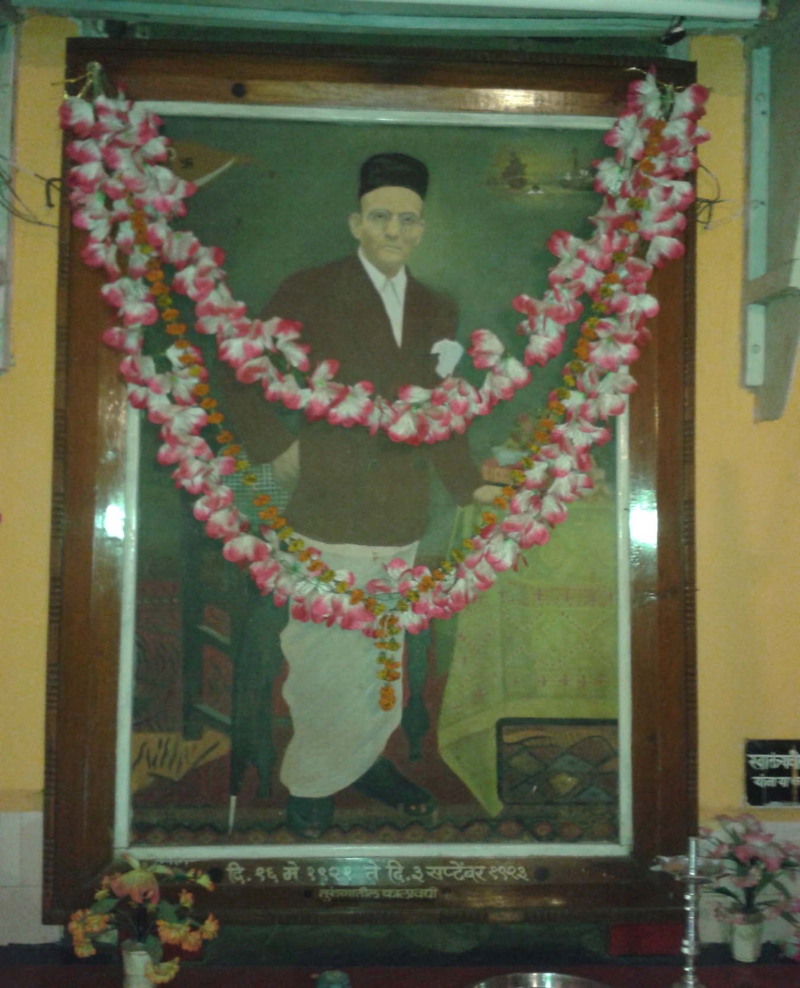
Ã¾ÖÖŸÖÓ¡Ö¾Öß¸üü ×¾Ö­ÖÖµÖú ¤üÖ´ÖÖê¤ü¸ü ÃÖÖ¾Ö¸üú¸ü µÖÖÓ“µÖÖ úÖêšü›üß“Öê ¯ÖÏ¾Öê¿Ö¾¤üÖ¸ü
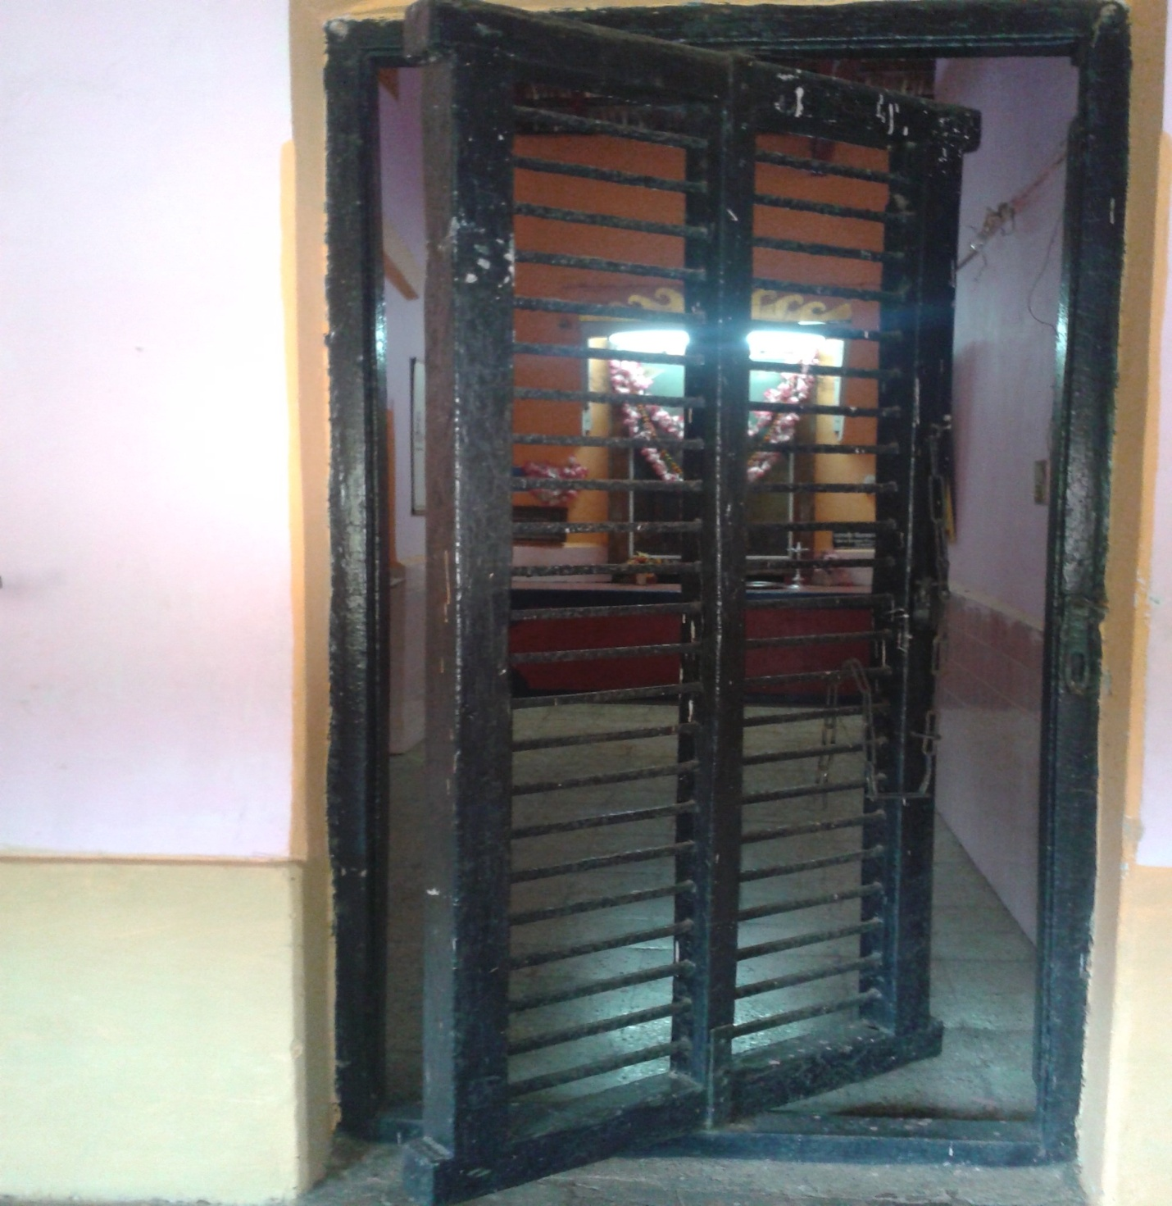
Ã¾ÖÖŸÖÓ¡Ö¾Öß¸ü ×¾Ö­ÖÖµÖú ¤üÖ´ÖÖê¤ü¸ü ÃÖÖ¾Ö¸üú¸ü µÖÖÓ­ÖÖ ‘ÖÖ»ÖµÖÖŸÖ †Ö»Öê»µÖÖ ÆüÖŸÖú›üß ,ÃÖÖÖôû¤Óü›ü ¾Ö ¤Óü›üÖ²Öê›üß µÖÖÓ“Öê ”ûÖµÖÖ×“Ö¡Ö.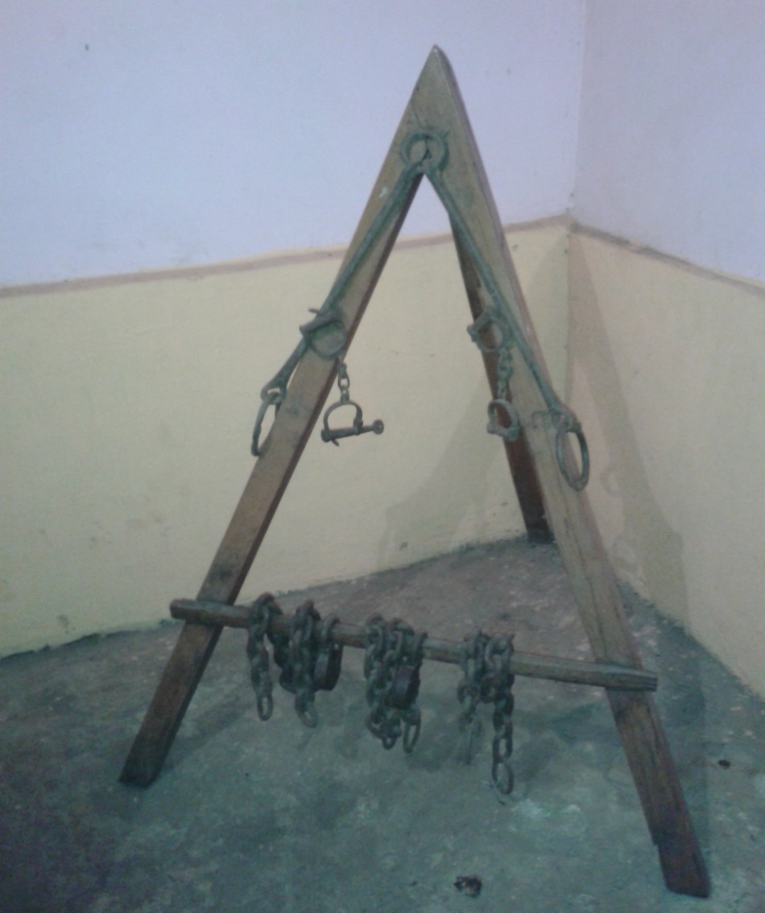
Ã¾ÖÖŸÖÓ¡Ö¾Öß¸ü ×¾Ö­ÖÖµÖú ¤üÖ´ÖÖê¤ü¸ü ÃÖÖ¾Ö¸üú¸ü µÖÖÓ“Öß •Ö­´ÖãÓú›ü»Öß ¾Ö ÃÖÊÖ êú»Öê»µÖÖ ÆüÃŸÖ´Öã¦üÖ †ÃÖ»Öê»Öê ”ûÖµÖÖ×“Ö¡Ö.
